Exp. 1 Design an LED flasher

Circuit Diagram:

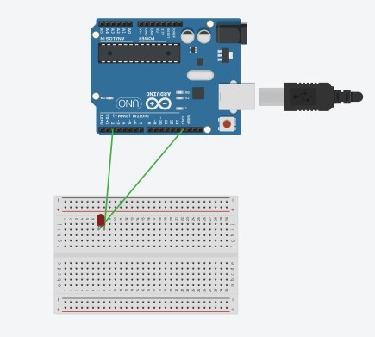

Theory: LED Flasher are semiconductor integrated circuits used to turn on and off groups of light emitting diodes either sequentially or according to a programmed pattern. They are found in circuits used as indicators and controllers, as well as in home-built projects.

Learning & Observation :

1. Observed Blinking of LED.
2. Working of Arduino.
3. Different sections of Arduino.
4. Coding for Arduino to blink a LED.

Precautions:

1. There should not be any loose connection in the circuit.
2. Code should be written properly.
3. Arduino should be attached to pc/laptop properly.

Code:

void setup()

{

pinMode(2, OUTPUT);

}

void loop()

{

digitalWrite(2, HIGH); delay(1000); // Wait for 1000 millisecond(s) digitalWrite(2, LOW); delay(1000); // Wait for 1000 millisecond(s)

}